**Appendix:**

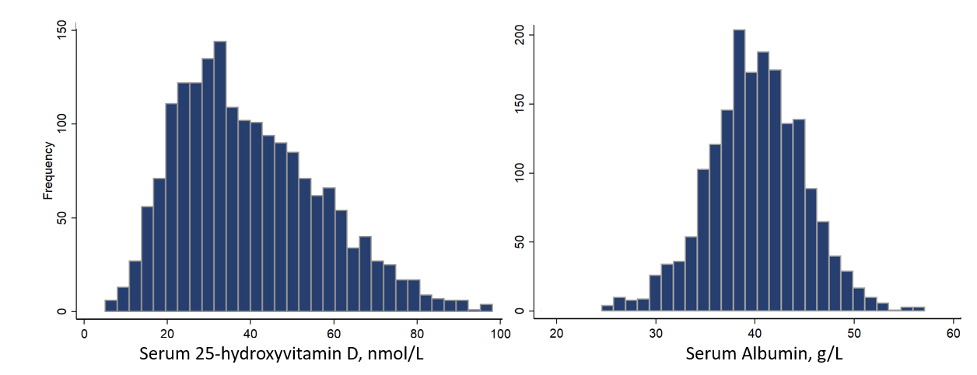

**Figure S1.** Distribution of Serum 25-hydroxyvitamin D and Albumin levels of the participants at baseline.

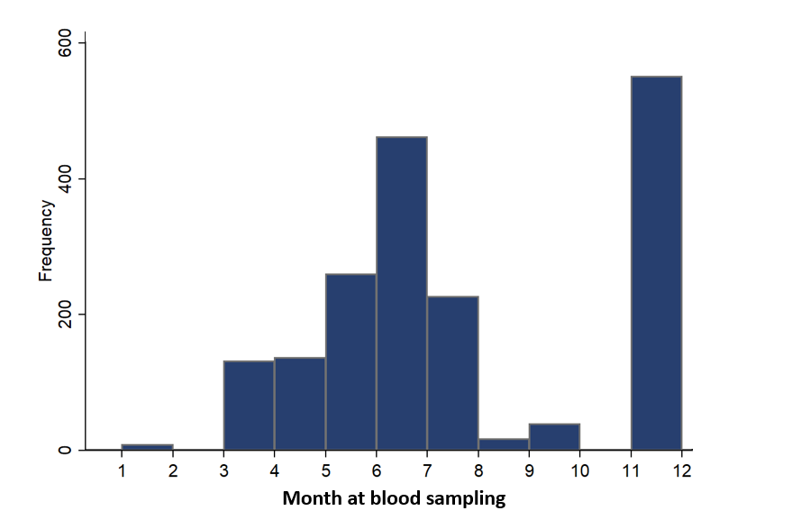

**Figure S2.** Distribution of the blood collection times at baseline.



**Figure S3.** Gender specific Kaplan-Meier estimates of survival by quartiles of serum vitamin D and albumin levels.

# 

**Figure S4.** Stratified analysis on association between serum 25(OH)D levels and all-cause mortality according to the albumin subgroup. Model was adjusted for age at baseline, sex, residency, residential province, education level, body mass index, smoking and drinking status, current exercise status, season of the blood sample collection, frequency of vitamin supplements using, cognitive function, activities of daily living, serum creatine, cholesterol, and high-sensitivity c-reactive protein level.

|  |  |  |  |
| --- | --- | --- | --- |
| **Table S1.** Comparison of the Baseline Characteristics between the Participant who were Enrolled or Lost of Follow-up | | | |
| **Characteristics a** | **Main analysis** | **Lost follow up** | ***P-*value** |
| **n=1,834** | **n=333** |  |
| 25(OH)D (nmol/L), mean ± SD | 39.89±17.24 | 46.33±17.86 | < 0.001 |
| Albumin (g/L), mean ± SD | 40.05±4.95 | 39.40±5.27 | 0.029 |
| Creatine (mmol/L), mean ± SD | 81.08±29.55 | 87.85±29.77 | < 0.001 |
| High-sensitivity c-reactive protein, mg/L | 3.45±8.26 | 4.28±10.22 | 0.11 |
| Total cholesterol (mmol/L), mean ± SD | 4.28±0.98 | 4.25±1.05 | 0.58 |
| Marital status, currently married and living with spouse | 702±38.3 | 144±43.2 | 0.14 |
| Age (year), mean ± SD | 85.6±12.3 | 84.4±12.3 | 0.10 |
| Gender, women | 804 (43.8) | 162 (48.6) | 0.10 |
| Education, 1+ years of schooling | 666 (36.3) | 146 (43.8%) | 0.010 |
| Residency, rural residents | 1535 (83.7) | 242 (72.6%) | < 0.001 |
| Smoking. ever smoker | 441 (24.0) | 94 (28.2%) | 0.10 |
| Drinking, ever drinker | 280 (15.3) | 48 (14.4%) | 0.69 |
| Exercise, regular exercise | 1744 (95.1) | 302 (90.7%) | 0.0013 |
| BMI (kg/m2), mean ± SD | 20.88±3.70 | 20.55±3.54 | 0.14 |
| ADL impairment | 312 (17.0) | 53 (15.9) | 0.63 |
| Vitamin supplements |  |  | 0.79 |
| Almost everyday | 56 (3.1) | 8 (2.4) |  |
| Occasionally | 168 (9.2) | 32 (9.6) |  |
| Rarely or never | 1630 (88.9) | 296 (88.9) |  |
| Season of the blood sample collection |  |  | < 0.001 |
| Spring (March–May) | 540 (29.4) | 103 (30.9) |  |
| Summer (June–August) | 713 (38.9) | 129 (38.7) |  |
| Autumn (September–November) | 305 (16.6) | 29 (8.7) |  |
| Winter (December to February) | 296 (16.1) | 75 (22.5) |  |

**Note:** 25(OH)D: 25-Hydroxyvitamin D; BMI: Body Mass Index; ADL: Activities of Daily Living; MMSE: Mini-Mental State Examination; a Numbers shown are n (%) unless otherwise noted.

|  |  |  |
| --- | --- | --- |
| **Table S2.** Sensitivity Analysis on Association between Serum 25(OH)D/Albumin Levels and All-cause Mortality by further Adjusting for Five Self-reported Disease | | |
|  | Categories | Hazard ratio,  (95% CI) |
| 25(OH)D, nmol/L | Quartile 1(>51.1) | Ref. |
|  | Quartile 2 (51.1-37.0) | **1.30 (1.03–1.63)** |
|  | Quartile 3 (37.0-26.9) | **1.34 (1.06–1.70)** |
|  | Quartile 4 (<26.9) | **1.76 (1.38–2.23)** |
| Albumin, g/L | Quartile 1 (>43.3) | Ref. |
|  | Quartile 2 (43,3-40.1) | **1.20 (0.96–1.51)** |
|  | Quartile 3 (40.1-37.0) | **1.45 (1.16–1.83)** |
|  | Quartile 4 (<37.0) | **1.91 (1.49–2.44)** |

Cox model was adjusted for age at baseline, sex, residency, residential province, education level, body mass index, smoking and drinking status, current exercise status, season of the blood sample collection, frequency of vitamin supplements using, mini-mental state examination score, activities of daily living, serum creatine, cholesterol, high-sensitivity c-reactive protein level, five kinds of self-reported diseases (hypertension, diabetes mellitus, heart disease, stroke and respiratory disease). For boldface data, *P* value < .05.

|  |  |  |
| --- | --- | --- |
| **Table S3.** Sensitivity analysis on Association between Serum 25(OH)D/Albumin Levels and All-cause Mortality by Comprising the Loss of Follow-up Participants (n=331) | | |
|  | Categories | Hazard ratio,  (95% CI) |
| 25(OH)D, nmol/L | Quartile 1(>51.1) | Ref. |
| Quartile 2 (51.1-37.0) | **1.27 (1.02–1.58)** |
| Quartile 3 (37.0-26.9) | **1.33 (1.08–1.65)** |
| Quartile 4 (<26.9) | **1.74 (1.40–2.16)** |
| Albumin, g/L | Quartile 1 (>43.3) | Ref. |
| Quartile 2 (43,3-40.1) | **1.45 (1.02–2.06)** |
| Quartile 3 (40.1-37.0) | **1.57 (1.11–2.23)** |
| Quartile 4 (<37.0) | **2.00 (1.38–2.89)** |

Cox model was adjusted for age at baseline, sex, residency, residential province, education level, body mass index, smoking and drinking status, current exercise status, season of the blood sample collection, frequency of vitamin supplements using, mini-mental state examination score, activities of daily living, serum creatine, cholesterol, high-sensitivity c-reactive protein level, five kinds of self-reported diseases (hypertension, diabetes mellitus, heart disease, stroke and respiratory disease). For boldface data, *P* value < .05.

|  |  |  |  |  |
| --- | --- | --- | --- | --- |
| **Table S4 Sensitivity Analysis on Association between Serum 25(OH)D Level and All-cause Mortality by using the Clinically Defined Cutoffs** | | | | |
| 25(OHD) | Severely deficiency | Deficiency | Insufficiency | Sufficiency |
| <25 nmol/L | 25 to <50 nmol/L | 50 to <75 nmol/L | ≥75 nmol/L |
| n | 390 (21.3%) | 949 (51.7%) | 428 (23.3%) | 67 (3.7%) |
| Model 1 | Ref. | **0.75 (0.64 - 0.88)** | **0.57 (0.45 - 0.73)** | **0.38 (0.23 - 0.61)** |
| Model 2 | Ref. | **0.75 (0.64 - 0.88)** | **0.57 (0.45 - 0.72)** | **0.38 (0.23 - 0.62)** |

Model 1 was adjusted for age at baseline, sex, residency, residential province, education level, body mass index, smoking and drinking status, current exercise status, season of the blood sample collection, frequency of vitamin supplements using, mini-mental state examination score, activities of daily living, serum creatine, cholesterol, high-sensitivity c-reactive protein level. Model 2 was additionally adjusted for five kinds of self-reported diseases (hypertension, diabetes mellitus, heart disease, stroke and respiratory disease). For boldface data, *P* value < .05.